
ROTATOR CUFF EXERCISES

BEFORE YOU START:

The exercises described below can help you strengthen the muscles in your shoulder (especially the muscles of the rotator cuff--the part that helps with circular motion). These exercises should not cause you pain. If you feel any pain, stop exercising. Start again with a lighter weight.
Look at the pictures with each exercise so you can use the correct position. Warm up before adding weights. To warm up, stretch your arms and shoulders, and do pendulum exercises. To do pendulum exercises, bend from the waist, letting your arms hang down. Keep your arm and shoulder muscles relaxed, and move your arms slowly back and forth. Perform the exercises slowly: Lift your arm to a slow count of 3 and lower your arm to a slow count of 6.
Keep repeating each of the following exercises until your arm is tired. Use a light enough weight that you don't get tired until you've done the exercise about 20 to 30 times. Increase the weight a little each week (but never so much that the weight causes pain). Start with 2 ounces the first week. Move up to 4 ounces the second week, 8 ounces the next week and so on.
Each time you finish doing all 4 exercises, put an ice pack on your shoulder for 20 minutes. It's best to use a plastic bag with ice cubes in it or a bag of frozen peas, not gel packs. If you do all 4 exercises 3 to 5 times a week, your rotator cuff muscles will become stronger, and you'll get back normal strength in your shoulder.

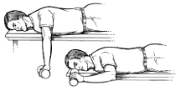
Exercise 1
Start by lying on your stomach on a table or a bed. Put your left arm out at shoulder level with your elbow bent to 90° and your hand down. Keep your elbow bent, and slowly raise your left hand. Stop when your hand is level with your shoulder. Lower your hand slowly. Repeat the exercise until your arm is tired. Then do the exercise with your right arm.

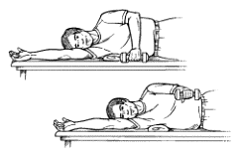
Exercise 2
Lie on your right side with a rolled-up towel under your right armpit. Stretch your right arm above your head. Keep your left arm at your side with your elbow bent to 90° and the forearm resting against your chest, palm down. Roll your left shoulder out, raising the left forearm until its level with your shoulder. (Hint: This is like the backhand swing in tennis.) Lower the arm slowly. Repeat the exercise until your arm is tired. Then do the exercise with your right arm.

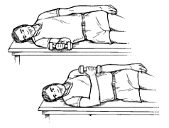
Exercise 3
Lie on your right side. Keep your left arm along the upper side of your body. Bend your right elbow to 90°. Keep the right forearm resting on the table. Now roll your right shoulder in, raising your right forearm up to your chest. (Hint: This is like the forehand swing in tennis.) Lower the forearm slowly. Repeat the exercise until your arm is tired. Then do the exercise with your left arm.

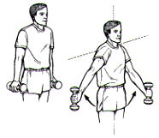
Exercise 4
In a standing position, start with your right arm halfway between the front and side of your body, thumb down. (You may need to raise your left arm for balance.) Raise your right arm until almost level (about a 45° angle). (Hint: This is like emptying a can.) Don't lift beyond the point of pain. Slowly lower your arm. Repeat the exercise until your arm is tired. Then do the exercise with your left arm.

